# Crust Busters

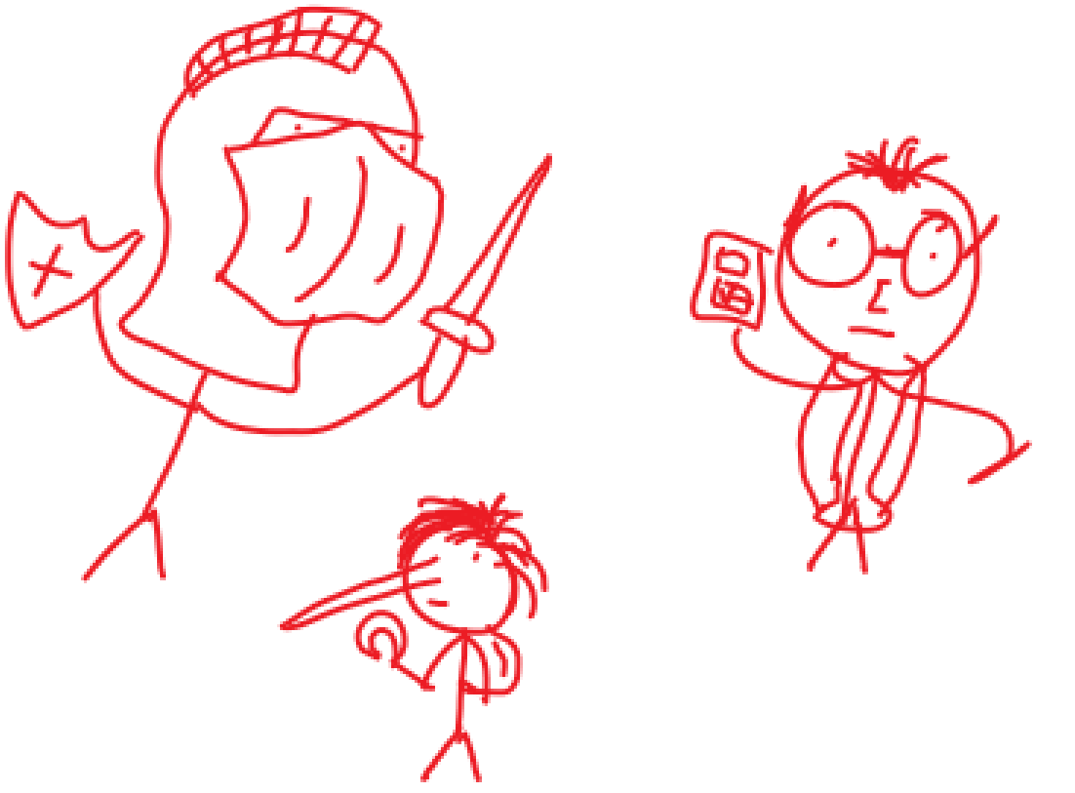

# links

**GitHub Portfolio:** [**https://tommyd450.github.io/Crust-Studios-Pitch/**](https://tommyd450.github.io/Crust-Studios-Pitch/)

**Twine Game:** <https://tommyd450.github.io/Crust-Studios-Pitch/Crust_BustersFin.html>

# Game Summary / Game Story

## Act 1

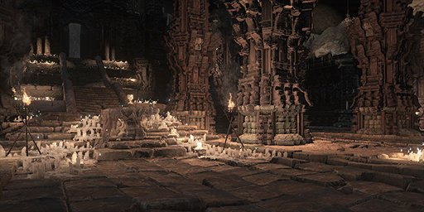The party of 3 are flying through space, looking for new inhabitable planets to mark for future colonisation. During their mission, they happen upon a planet with unprecedented seismic activity. The scientist pushes the party to go and investigate said activity. As they approach the planet, the spaceship is violently pulled towards the planet’s surface and crashes. Cuts to black and a few hours pass. When we come back to our heroes, they are bruised and scarred but nothing serious. With great effort they crawl out of the spaceship. They take in their surroundings. Colossal mountains surround them, and the landscape itself is very rocky and devoid of vegetation. The scientist scans the horizon for any points of interest and notices that in one of the distant mountain faces lies a decrepit, ancient temple carved into the mountain side. The scientist tells the knight and spelunker to head in and investigate while he works on the ship. The two make their way into the temple. Upon entering, the two find themselves in a vast open chamber with crumbling pillars lining the centre path. At the centre of the chamber, floats a mysterious, white orb. The orb pulses periodically creating powerful vibrations. The two approach the orb with caution, observing the orb. While the spelunker is pacing around, thinking to himself, the knight mindlessly reaches for the orb. Upon touch, the orb changes to red and cracks open. Evil spirits rush out of the orb, draining the orb of its red colour and leaving it clear. The Temple begins to collapse, and our heroes make their way out.

## act 2

Cut to the scientist fixing the ship, as he finishes the repairs, he hears a loud rumbling. He turns around and sees the ancient temple crumble in the distance with red smoke arising from the cracks. The knight and spelunker come rushing back and urge the scientist to head inside the spaceship and lift off. As the scientist starts the spaceship, the red smoke forms a thick barrier in the atmosphere, the party tries to fly into space but are quickly stopped by said barrier. Floating mid-air the party is forced to watch a part of the smoke transform and take the shape of each party member. The silhouettes separate and each one plunges into the ground, raising new temples in the spots they struck. Knowing they can’t escape, our adventurers land once again, determined to reseal the evil. The party makes their way through each one of the temples, the objective in each temple is to use the orb at the end to reseal each respective spirit.

## scientist’s temple

This temple is filled with traps and puzzles that mainly the scientist can solve with the help of the knight and spelunker. At the end, the party must solve the most difficult puzzle yet, by solving it, they get access to the orb that reseals the scientist’s silhouette.

## spelunker’s temple

This temple will be heavily based on parkour and scaling obstacles, the spelunker will be of most help here, with the occasional help from his party using their own abilities. At the end, the party will have to scale to the top of the temple, where they will find the orb to reseal the spelunker’s silhouette.

## knight’s temple

The knight’s temple will put a heavy emphasis on combat, where the knight will be the centre character. The scientist and spelunker will provide backup. At the end of this temple the knight and his party members must fight off a horde of smoke demons to get to the orb to reseal the knight’s silhouette. When the third tower is complete, a 4th bigger tower comes up from the ground, with a large translucent orb floating on top of it. Our heroes make their way to it, upon entrance, the doors of the tower seal shut, locking the heroes inside. The heroes make their way through the temple using all the skills and abilities they learned in the previous temples. Once at the top, the heroes have the orb in their sight and upon approaching they get interrupted by an amalgamation of all 3 previous silhouettes.

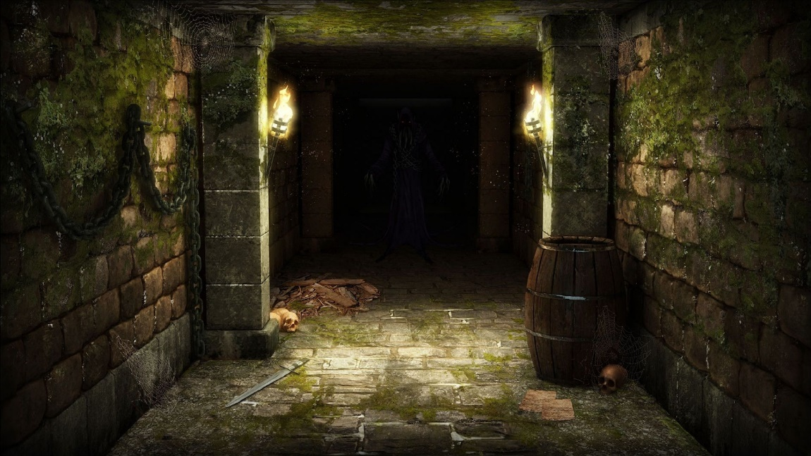

## Act 3

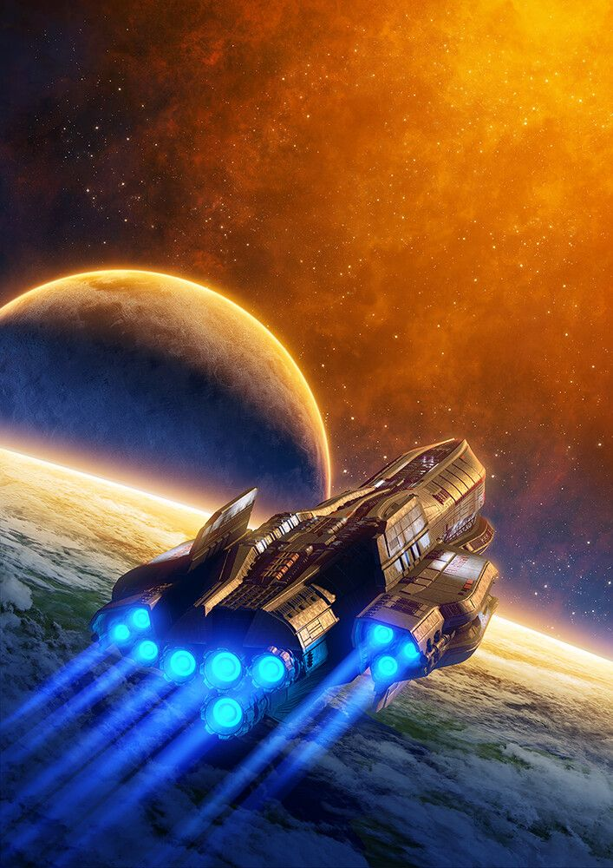Upon defeating the last spirit, the knight makes his way to grab the orb. Before touching it, the scientist stops him and directs his attention to a mural behind the orb. On the mural is a depiction of a man holding the orb and having his life sucked out. Upon discussing the issue, the knight takes on the responsibility of sacrificing himself to reseal the evil spirit. He does this to redeem himself for being the one who released it in the first place. The knight sacrifices himself and all the smoke gets sucked back into the orb. Once all the smoke is sucked back into the orb, the knight's body collapses and turns into dust and another strong wave of vibrations occurs. Shaking the foundations of the temples and crumbling them do the ground. The scientist and spelunker quickly make their way down the temple, making it just in time before the temple fully collapses. The two get into the spaceship and leave the planet.

# characters

## Knight:

The Knight is a core member of the group of adventurers sent out to investigate planets for the possibility of colonisation. Even though his codename may be The Knight, the only things he shares with a knight are his sense of justice and morality and his combat prowess. Favouring guns instead of swords and shields, the knight prefers to deal with problems head on without thinking much about them. His main role in the group is to deal with any combat related issues such as taking care of enemies with speed and efficiency or taking on foes that are too strong for his comrades The Spelunker and The Scientist. He can also move around boulders and other large structures due to his high strength.

The Knight’s main motivation is to serve his King who sent him on this mission, ready to put his very life on the line for the sake of the mission. He is a tall, tanned hunk of pure muscle, with short hair. Wearing special armour that is both flexible and has high defence, the knight can tank a lot of damage as well as quickly dodge out of the way. He dreams that one day he will be able to serve as the top commander in the King’s elite bodyguards and as such he will take on any task given to him no matter how dirty or dangerous. The knight always puts others before himself, ready to put his life on the line for his teammates. Being such a morally right person, he despises people with no loyalty and those that have no problem sacrificing fellow teammates to achieve what they want. It is these characteristics that gave him the nickname of “The Knight”.

## spelunker:

The Spelunker is an intrepid explorer always prepared for whatever the environment throws at them having everything they will need on them or at least nearby. Since a young age the spelunker has always been a very curious person from an early age and has always been the person to take the road less travelled by just out of sheer curiosity, always taking the longest route to somewhere just to see what that route has to offer. Eventually they would train in various forms of navigation and traversal leaving almost no environment on their home-world that the spelunker could not travel across. From there many years of exploring and traversing the Spelunker gained a great interest in cave’s and their composition. Their homeworld had however already been fully explored and mapped long before they were born. Longing to be remembered alongside those famous explorers the Spelunker set their eyes to the stars. A huge universe with billions upon billions of planets ripe for exploration and mapping. With all of their accumulated knowledge the spelunker hopes that they can use it to help them traverse alien worlds in the hopes of being remembered as a legendary explorer who went above and beyond. However, upon the beginning of their expedition the spelunker began to realise that space exploration wasn’t as exciting as they thought it would be.

## scientist:

The scientist is a highly intelligent problem solver that has inventions ready for any situation. He uses his inventions to support his team. Ever since he was young, he has been experimenting with new inventions to improve his family and friends lives. The scientist prefers to work out and plan his actions methodically instead of just taking actions spontaneously. He wears a long white lab coat, a utility belt, and black glasses. He is a tall and pale looking man with the power to analyse his environment and take the best action for himself and the team. He always puts logic ahead of everything else. Because of this, he appears emotionless but sees himself as the one responsible for everyone’s lives and always uses his knowledge to guide his teammates. He tends to stay out of combat when he can, leaving that to the skilled team members such as the knight. He practices his inventing skills every day, constantly experimenting and striving for improvement to become an irreplaceable and valuable member on the team.

The scientist’s main motivation is making other people’s lives easier with his inventions and helping people when he can with his vast problem solving and puzzle skills. He is constantly looking for puzzles and problems to solve to keep his mind awake and ticking. He wishes to explore the deep space around him, in search of new materials and elements that he can then study and use for future inventions. He wants to be remembered for his contributions to guiding his team, discovering new planets and materials, and his contributions to society with his ground-breaking inventions that will assist many people in their lives.

# gameplay overview

Crust Busters is a 3D, single-player, third-person, action, adventure, and puzzle game that finds a party of heroes consisting of: The Scientist, a highly intelligent problem solver who wishes to explore the deep-space around him, the Spelunker, an intrepid explorer who is always prepared for whatever the environment throws at her and the Knight, a brave and skilled fighter who protects his team from the evils they face. Using the party member’s unique skills, the player makes their way through each temple. The player climbs, fights off enemies and solves puzzles to triumph over the released evils. Be mindful, clues are hidden around the temples that are used later in puzzles so take note of what you find. Some puzzles and events have a countdown so don’t take too long in making your decision.

# gameplay experience

From the beginning, the player will feel as if they are standing on the shoulders of giants. The player will feel like they are a pawn on this mysterious planet, with no knowledge of what could be lurking in the rocks or on the mountains. When the evils are released, this feeling is only heightened. The player will feel the pressure of time on them as they attempt to complete puzzles before they are ripped to shreds. There are moments of humour in the game that will lessen the stress and pressure that is put on the player. Making it easier to focus and progress. As the player travels through the temples and defeats the respective evils, they will begin to feel like nothing can stop them, that is, until they reach the final boss, the amalgamation of each respective evil, who towers over the party. This will send the player back to the feeling of playing as a pawn. The player will soon realise that they cannot just beat this boss with pure strength, but instead they must outsmart the amalgamation. This will leave the player feeling accomplished as they had to think out their strategy rather than just running and gunning it. The player will be shocked at the realisation that one party member must be sacrificed in order to escape the planet. This feeling will quickly change into sadness and respect as the Knight volunteers himself as an act of redemption for releasing the evils in the first place. The player will be happy that they have escaped the planet but will also be upset as they think about the cost of getting there.

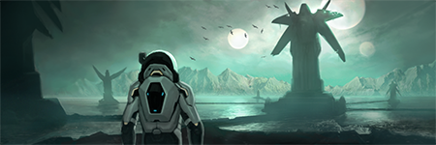

# mechanics and modes

Gameplay mechanics vary between each of its distinct party members.

## the knight:

Specialises in using their immense physical strength to overcome obstacles and to help the party.

This includes:

* Fighting off anything that may threaten the party.
* Lifting and pushing heavy objects to allow traversal across the vast and harsh temples.
* Destroying walls and creating openings in the dilapidated temples.
* Boosting the Spelunker up to places they cannot climb up to normally.

## the spelunker:

Specialises in their agility and traversal skills to jump, climb, and swing their way through the temples.

This includes:

* Climbing up to high places to discover alternate paths for the party.
* Using her grapple hook to set up swing points.
* Climbing through crawlspaces to open new paths.

## the scientist:

Specialises in using their vast intellect to decipher and solve the ancient temples mysteries.

This includes:

* Scanning rooms using the Crust Boy to detect possible structural weak points or panels.
* Deciphering ancient text to allow for better understanding of the environment around them.
* Solving the temple’s cryptic puzzles to allow the party to progress.

## Modes:

There is only one mode in Crust busters, being the main story mode.

# enemies and bosses

## the mistlets:

The mysterious red shroud released by the game’s protagonists begins to take shape. The shape it takes however resembles vaguely whomever dares to trespass upon their world. A single mistlet on its own is not very threatening but in groups they are very dangerous. They will at every opportunity available attempt to thwart the party’s progression and attempt to defeat and absorb them into the mysterious shroud which now layers the planet.



## dopplegangers

Like the mistlets but more intelligent. The red mist takes the form of each member of the party copying their personalities. The Scientist’s doppelganger observes coldly and as the party tries to solve puzzles. The Spelunker’s doppelganger plays on the Spelunker’s self-doubt on the decision to explore the universe. Each of the doppelganger’s represent each of the characters' bad tendencies and amplifies them to work against the party.

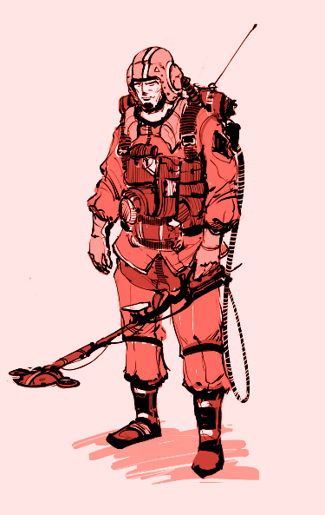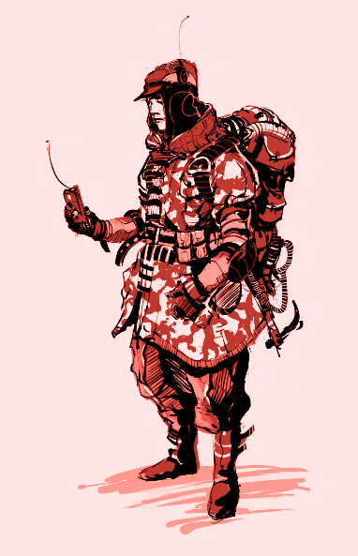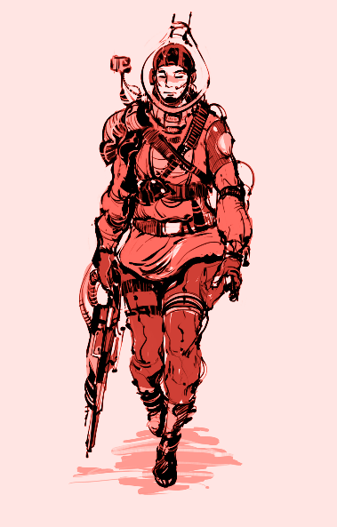

## boss: the chimera

The Chimera is a last-ditch attempt by the mist to remain out of its captivity. Personifying a combination of each of the protagonists. Formed out of desperation the beast is irrational and will lash out unpredictably in an attempt to stop the trio from resealing the mist.

# planned expansions and bonus material

## expansions:

The first planned expansion for Crust Buster will take place after the events of the main game. After the events of the main game the Spelunker and Scientist return to the accursed planet with several teams of researchers and scientists and a new member to their team! With the new resources available to them and a new party member they intend to uncover the mysteries of these temples and the accursed mists that they were shrouded in.

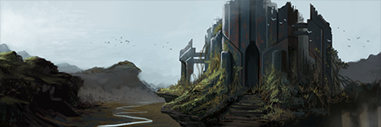

## bonus material:

There is no content such as collectibles in Crust Busters.

# playtesting

|  |  |  |  |  |  |
| --- | --- | --- | --- | --- | --- |
| Who | When | Where | What | Feedback | Response |
| Jack Noonan | 10/01/2021 | Discord | Knight Temple | Confused as to what a mistlets was. Struggled to solve the chandelier puzzle. Hard to imagine rooms/lack of description. Knight is dumb. | Level was tested apart from the game. Mistlets introduced prior to that level. Images were added to the game to help visualise rooms. Knight is supposed to be dumb |
| Alan Crean | 10/01/2021 | Discord | Knight Temple | Wanted an explanation as to what a mistlets was. Going back to hub was broken | Same as above the mistlets were introduced prior to the temple temple was standalone so this has been rectified. |
| Jack Fitzpatrick | 10/01/2021 | Discord | Spelunker Temple | Rooms should be a bit more detailed. More Mistlets confusion. Lack of visulisation in rooms. Felt the characters worked well together. | A little bit more detail was added to some rooms. Mistlet addressed the same as above. |
| Ciara Keogh | 10/01/2021 | Discord | Spelunker Temple | Rooms were bland. Was confused how the door was opened in room 2.2. Characters did not seem to have much of a relationship. Not enough options in some rooms Felt the rooms need images to understand what significance it had. | Some details were added to the rooms. How the door in 2.2 was opened has been specified better. Some images have been added throughout the temple |
| John Peter | 10/01/2021 | Discord | Scientist Temple | Was never lost/ knew where they were. Felt the rooms were described well. Felt characters should have interacted more outside of their mission. Felt character text should be colour coded as they kept reading certain line thinking they were another character. | Better notation was used for character's in dialogue after. |